Synthesis of Adipic Acid

**Reference:** Handout; Chemistry lessons: reactions of alkenes, oxidation reactions, polymers; Green lessons: alternative reagents and solvents, catalysis

**Purpose:** To oxidize cyclohexene to adipic acid using hydrogen peroxide as the terminal oxidant, sodium tungstate dihydrate as the oxidation catalyst, and aliquot 336 as the phase transfer catalyst

**Table of Reagents:**

|  |  |  |  |  |  |
| --- | --- | --- | --- | --- | --- |
| **Reagents** | **MW** | **Amount** | **BP (°C)** | **MP (°C)** | **Density** |
| NaWO4 | 293.8 g/mol | 0.5 g | - | 698 °C | 3.25 g/cm3 |
| Aliquot 336 | 404.16 g/mol | 0.5 g | 225 °C | -20 °C | 0.88 g/cm3 |
| Cyclohexene | 82.16 g/mol | 2 g | 83 °C | -103.5 °C | 1.45 g/cm3 |
| H2O2 | 34.01 g/mol | 11.98 g | 150.2 °C | -0.43 °C | 2.24 g/cm3 |
| KHSO4 | 136.17 g/mol | 0.37 g | 300 °C | 197 °C | 0.811 g/cm3 |

**Balanced Chemical Equation:**

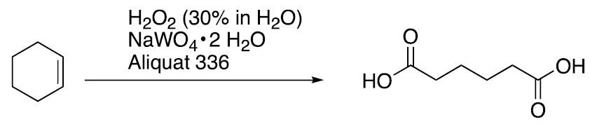

**Safety:**

* Aliquot 336 🡪 toxic and irritant
* H2O2 🡪 causes burns on contact with skin and eyes

|  |  |
| --- | --- |
| **Experimental Procedures** | **Data & Observations** |
| **1.** Obtain 50 mL round-bottom flask with condenser and stir bar | *Cyclohexene Used:* 1.7455 g |
| **2.** Add reagents in order:   1. 0.5 g sodium tungstate dihydrate 2. 0.5 g Aliquot 336 3. 11.98 g 30% H2O2 4. 0.37 g KHSO4   ***STIR WELL*** |  |
| **3.** Add 2.0 g cyclohexene; Heat to reflux on sand bath and continue to reflux for 1-2 hours; Maintain stirring until reaction mixture no longer separates to 2 layers |  |
| **4.** When reaction complete and still hot; pipette water layer off to small beaker. Wash round bottom flask with 5 mL of hot water and combine with other aqueous material! Cool beaker rapidly with ice bath to obtain crude crystalline product. Collect with Buchner funnel. |  |
| **5.**  Recrystallize using minimal hot water and obtain mass and mekting point of final product | *Collected Product:* 0.4368 g  *Melting Point:* 144.3 °C  *Product color:* White |

**Post-lab Questions:**

**1.** We collected 0.4368 g of adipic acid as well as the color of our product was white.

$$\% Yield= \frac{Product Obtained}{Theoretical Yield}×100$$

*Obtained:* 0.4368 g *Color:* White

* First, we must obtain the theoretical value of our Adipic Acid in grams:
$$1.7455 g Cyclohexene×\frac{1 mol Cyclohexene}{82.14 g Cyclohexene}×\frac{1 mol Adipic Acid}{1 mol Cyclohexene}×\frac{146.14 g Adipic Acid}{1 mol Adipic Acid}=3.1055 g Adipic Acid$$

* Next, we must use equation above to get our % Yield:
$$\% Yield=\frac{0.4368 g}{3.1055 g}×100=14.07\% yield$$

* *We received a 14.07% yield for our product*

**2.**

* *Melting Point for Adipic Acid:* 152.1 °C
* *Melting Point for our Product:* 144.3 °C

Our product experienced melting point depression as our crude product was not within range of the true melting point of pure adipic acid. Plausible impurities that might have resulted in our unpure product is water from not fully drying or our product might not have completely recrystallized from our solvent mixture. In addtion, we might have not refluxed fully to result in the complete synthesis of adipic acid from the given mixture.

**3. a.**

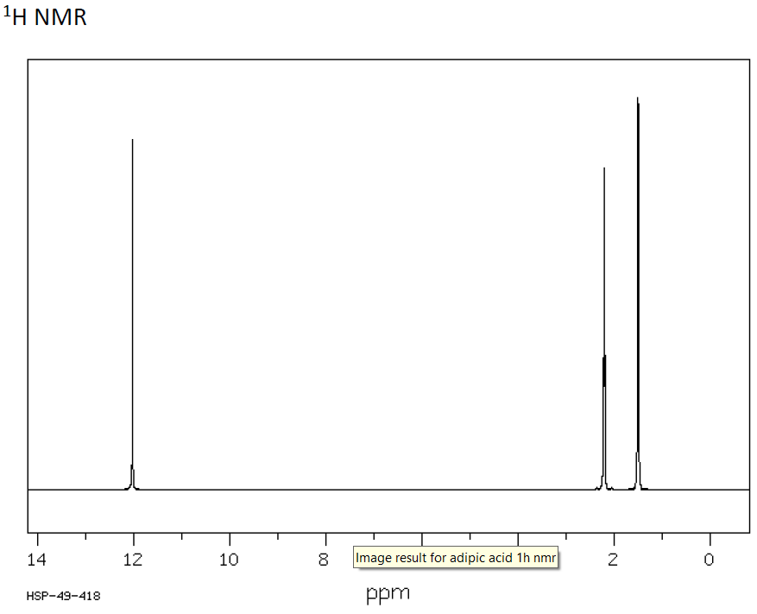



**b.**

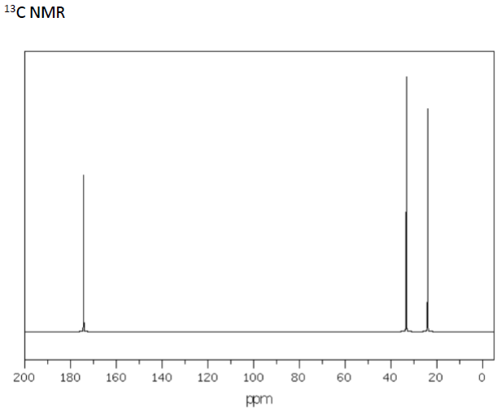



**c.**

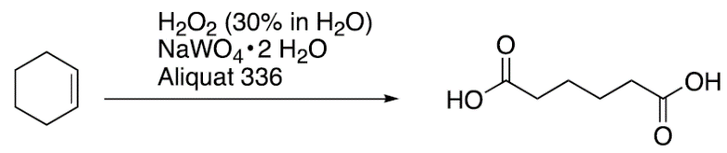 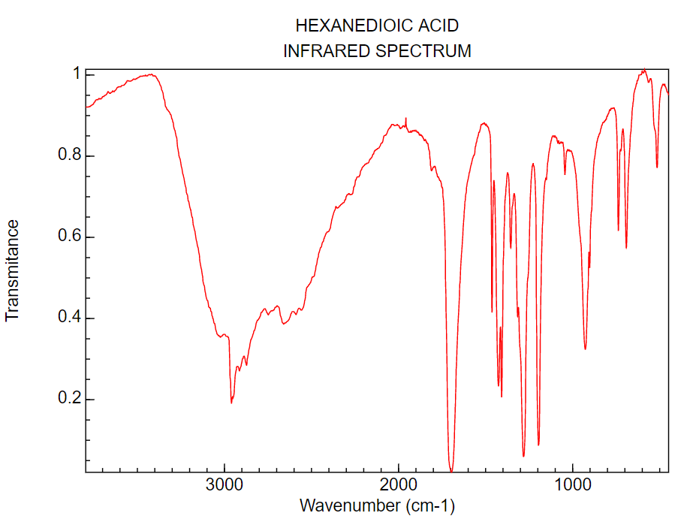

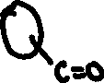

**4.** There are *4 oxidation reactions* involved in the pathway from cyclohexene to adipic acid. These oxidation reactions include epoxidation, alcohol oxidation, Bayer-Villeger oxidation, and hydroxyl oxidation.

**5. $Atom Economy \left(\%\right)= \frac{Molar Mass of Products}{Molar Mass of Reactants}×100$**

* *Products Molar Mass* = 146.14 g/mol (Adipic Acid)
* *Reactants Molar Mass* = 82.16 g/mol (cyclohexene) + (4 * 34.1 g/mol (H2O2)) = 218.56 g/mol

$$Atom Economy \left(\%\right)= \frac{146.14}{218.56}×100=66.86\%$$

**6.** The commercial synthesis of adipic acid involves the oxidation of cyclohexanol with nitric acid, which results in the production of nitrous oxide. Personal exposure to this hazardous gas can cause inflammation in the airways . Environmentally, the production of nitrous acid through the commercial synthesis of adipic aid can result in the depletion of the ozone layer. In addition, nitrous oxide is a greenhouse gas that can cause global warming as a result of rising temperatures. Furthermore, the production of this harmful gas can also destroy living organisms including plants through the fall of acid rain.